**P8**

**Undertake routine maintenance tasks on a standalone computer system.**

**Introduction**

In this assignment, I will be showing you a user-guide of the following procedures to make the computer user friendly. I will be showing the following:

* Organisation and naming of files
* Back-up procedures
* Automatic scheduling and deletion of unwanted data
* Archiving
* Defragmentation
* Deleting temporary files
* Cleaning hardware e.g. keyboard, mouse and display screen equipment (DSE)
* 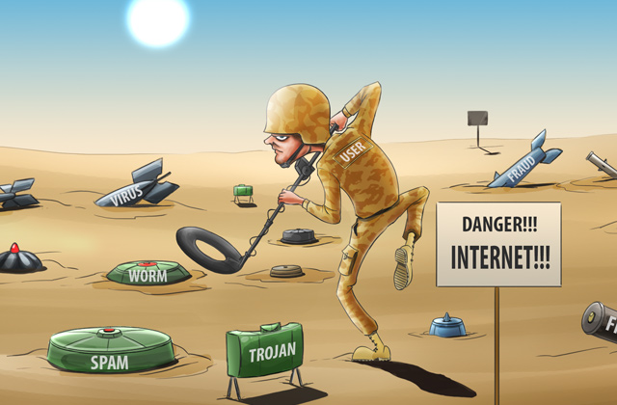Replacing consumables e.g. print paper; ink or toner cartridges; replacing damaged components

**Archiving**

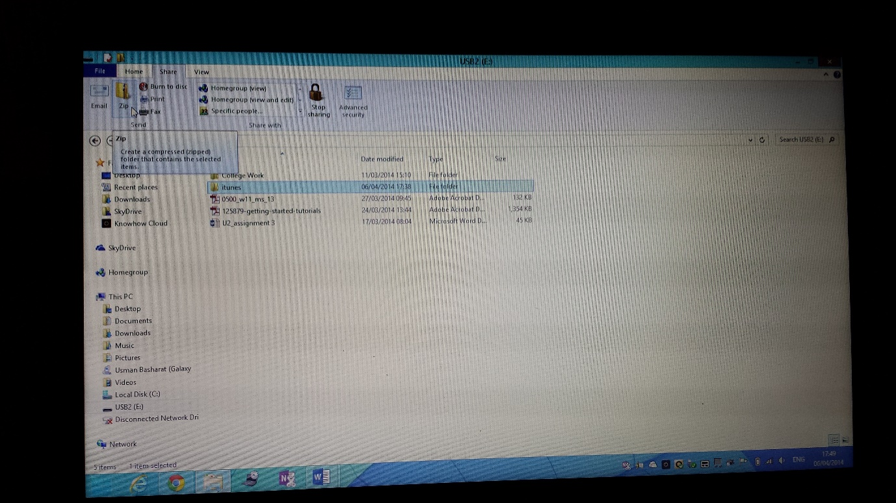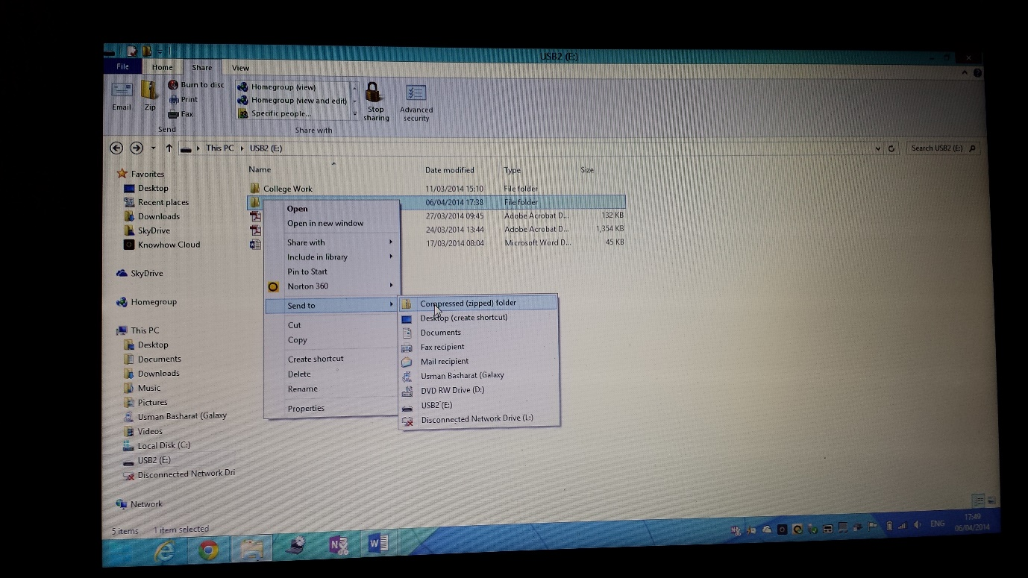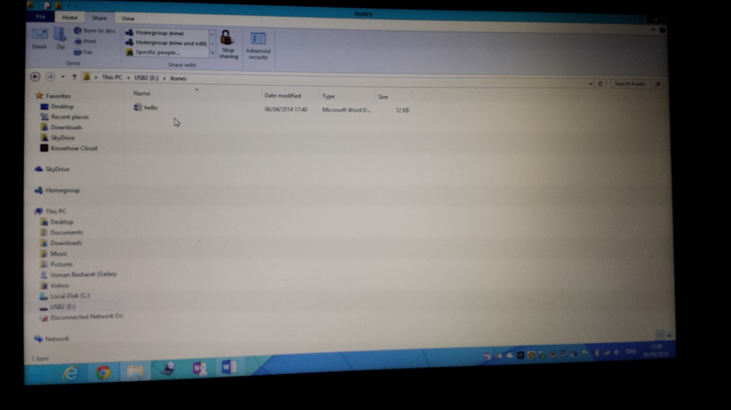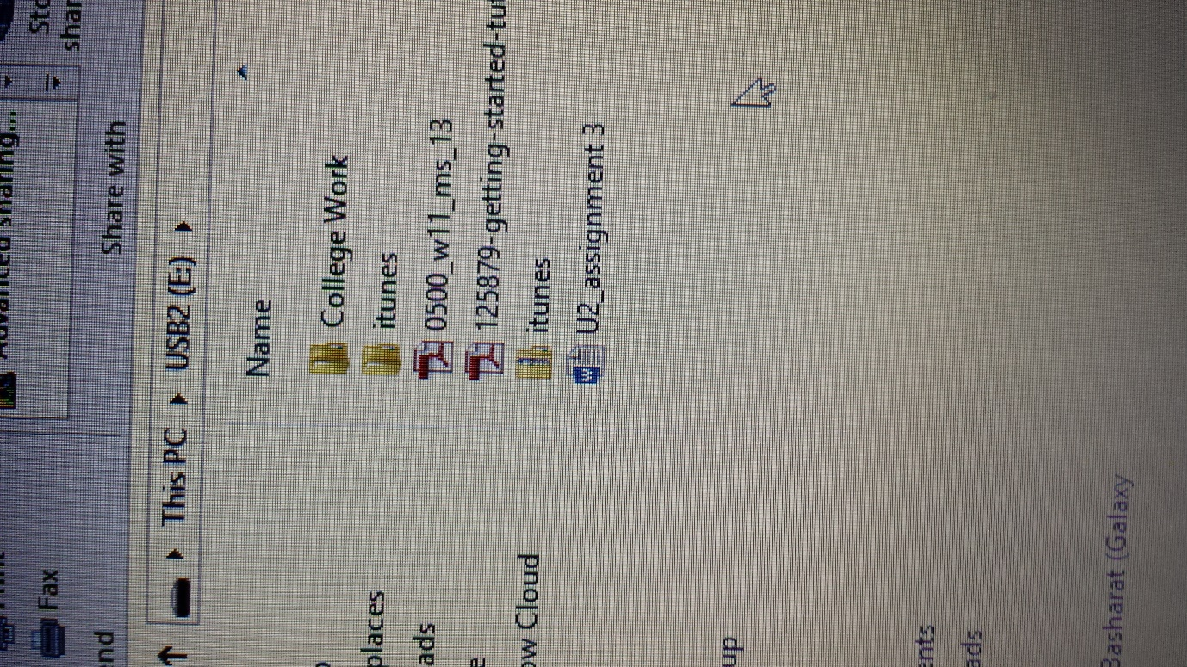In computing, archiving is storing something. In this case, we will need to zips the file. This compresses the file, and it you can send the file to anyone within it. You have to have a document/file inside the file. If the file is empty, you cannot archive the file. Once the document is inside, you will need to right-click on the file. You have to go on ‘SEND TO COMPRESSED (ZIPPED) FOLDER’. This creates another zipped file containing the document. The zip sign shows that the process is complete.

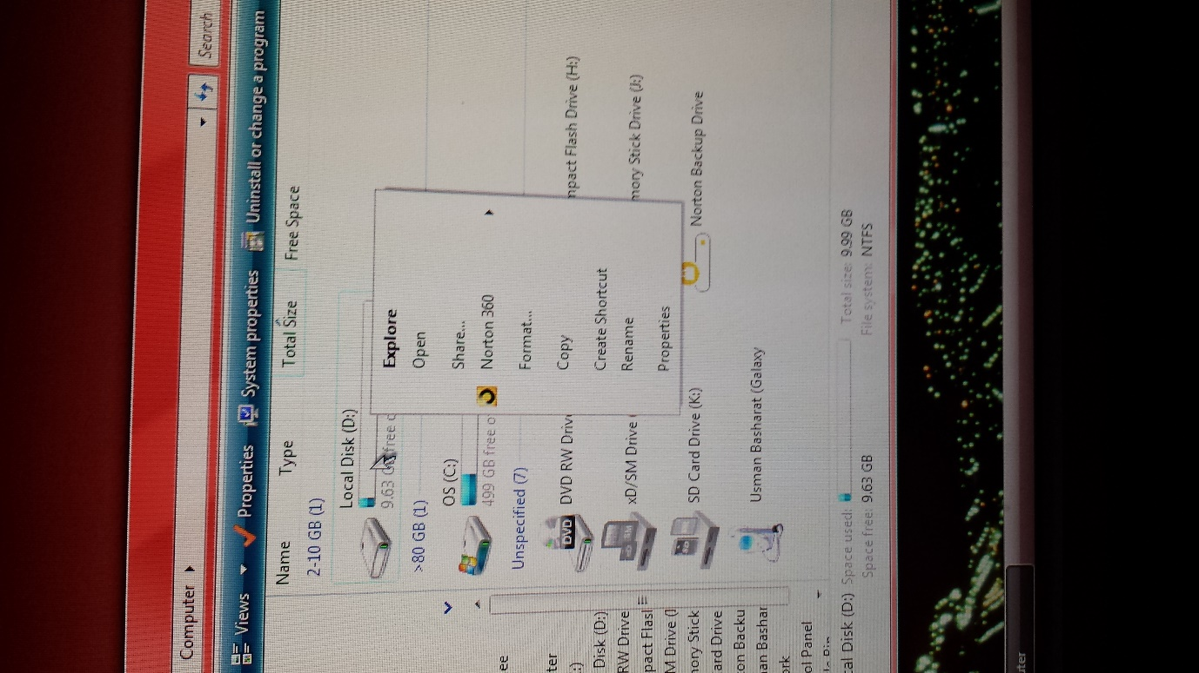**Defragmentation**

Defragmentation is getting rid of waste and replacing them with a good ones. If you want to complete this task, you will need to go on ‘computer’, and right-click on the disk you want to defragment. Go on ‘properties’ as it has been showed on the computer.

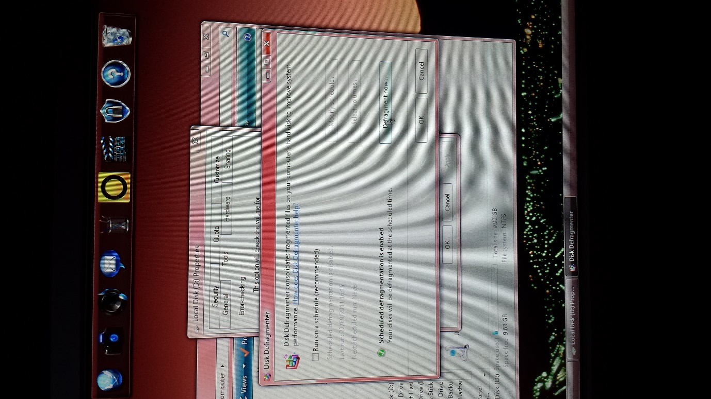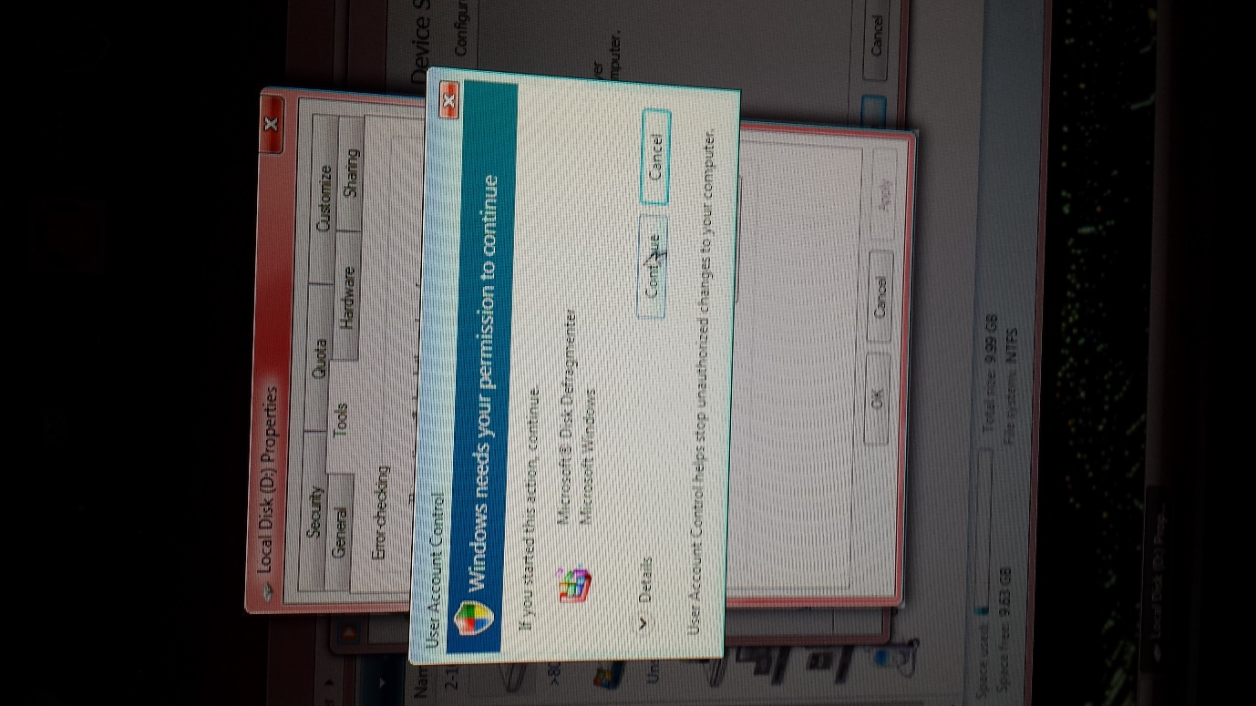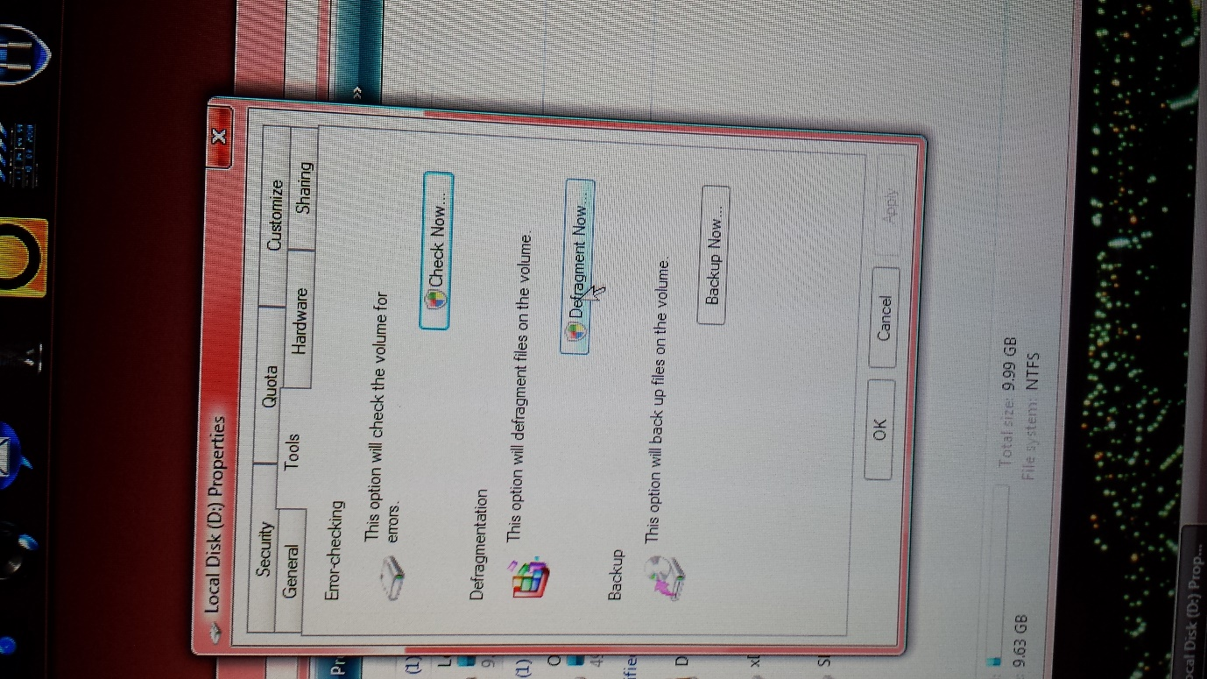You will see the image below and click defragment now. As I was using admin computer, you will need to confirm the password if you are not using an admin account.

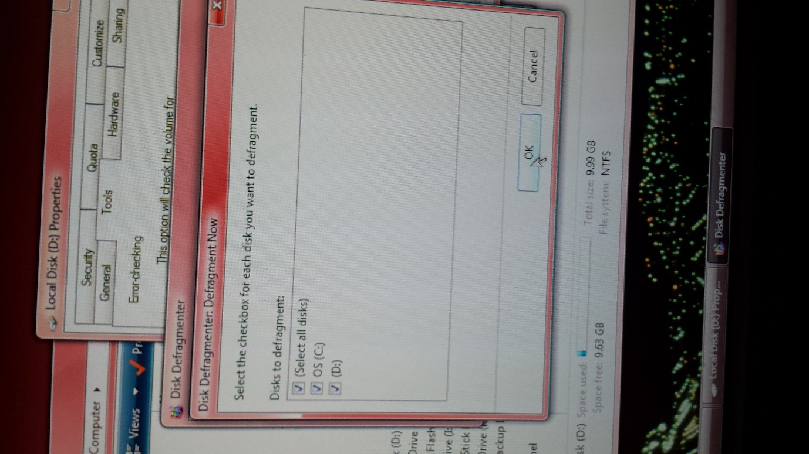You will need to defragment it but you can schedule when you want to do it. Click ‘Defragment now’ and select the disks you want to defragment.

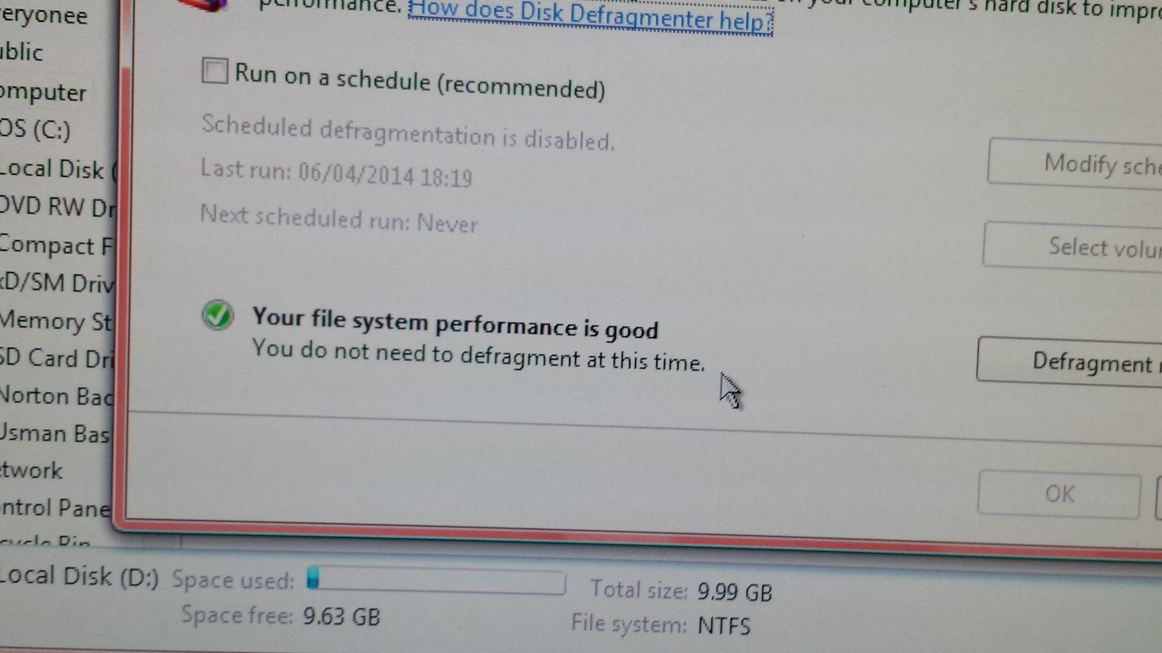

This tells us that the performance of this system is good. You do not need to defragment at this time.

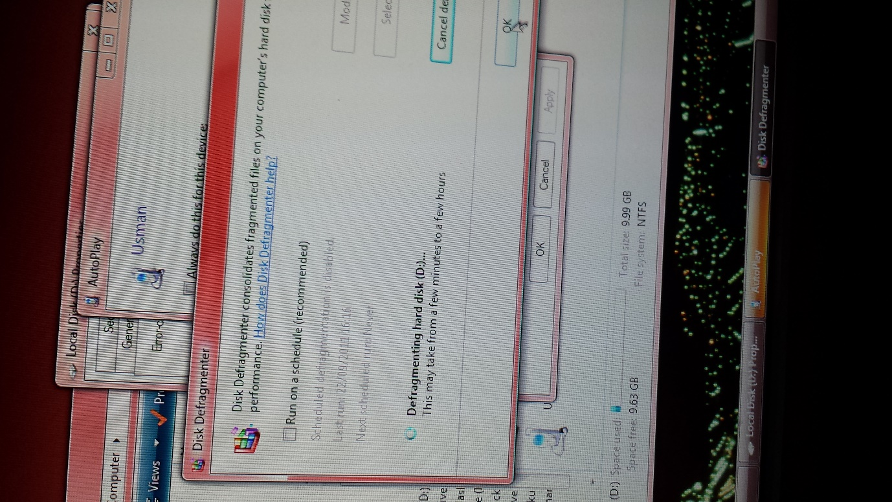As it says in the image, it will take more than 1 hour to complete. It will need time for the defragmentation to be complete. Once it is complete, it will be more fast and efficient. However, the disk defragmenter would need to analyse both disks, as it would take a few minutes.

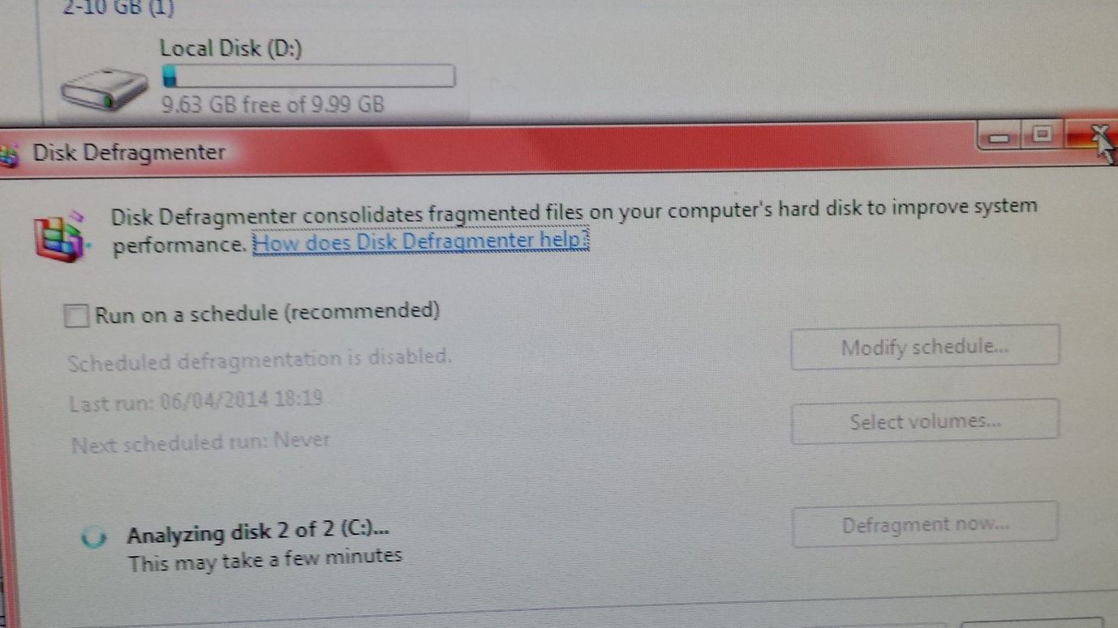

*NOTE* I DONE THIS ON WINDOWS 7, ON OTHER OPERATING SYSTEMS E.G. WINDOWS 8, IT WOULD BE DIFFERENT.

**Back-up procedures**

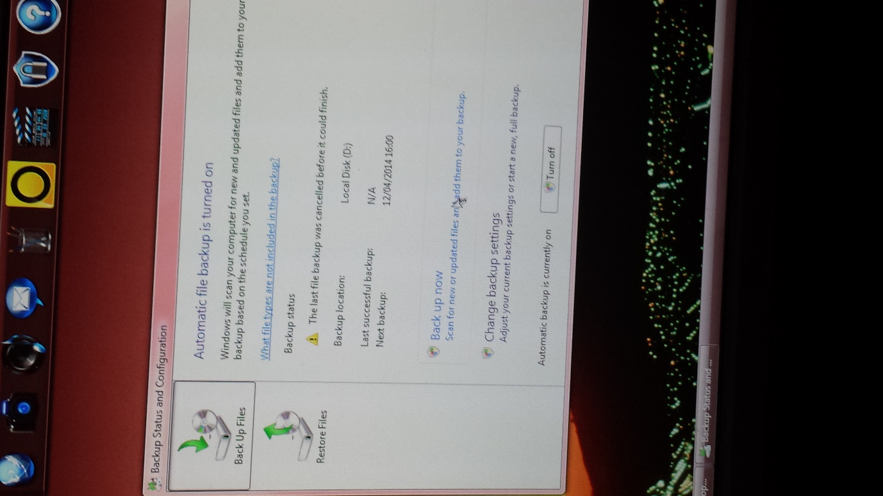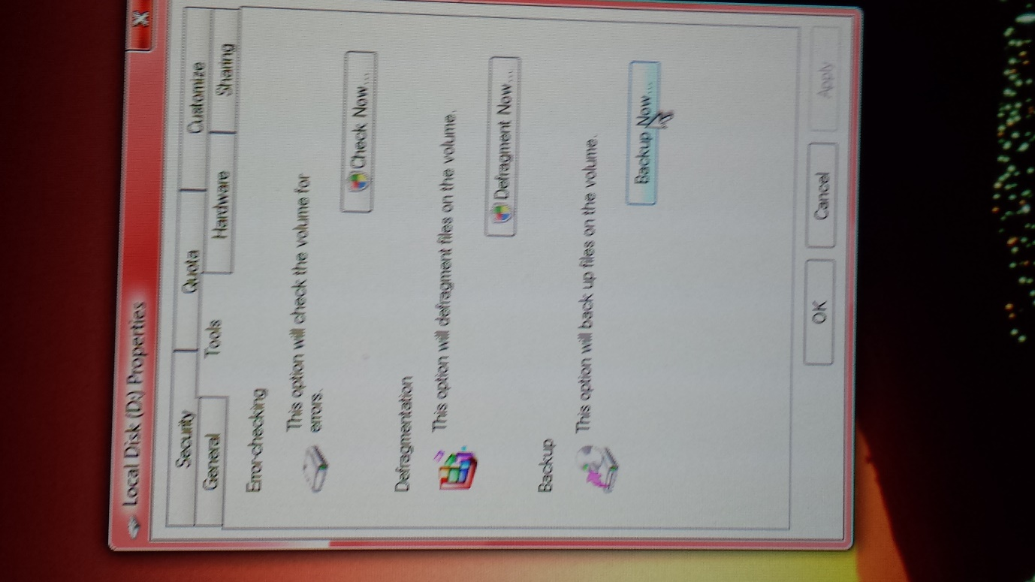It is the same process of getting to this procedure as **defragmentation.** You go on ‘computer’ and right-click on the disk drive. Click on properties and tools. This is where you will reach the stage of where the images shows you. Click ‘Backup now’ to proceed with Back-up. It is quite hard to navigate around of how to Back-up. You have to turn on the Automatic backup. This will enable the ‘Back up now’ sign and once you click on it, it would start to back-up your disk.

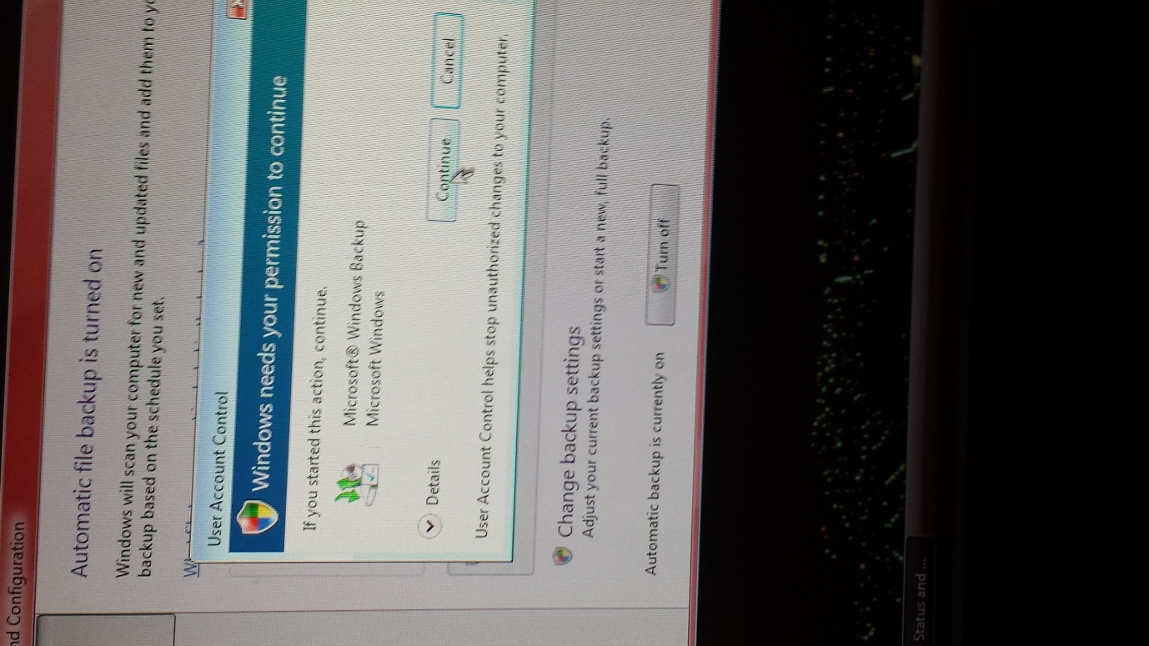As always, you need permission to continue. If it were necessary, you would need to put the administration password into it. Continue and proceed with the procedure.

**IT WILL BE COMPLETED ONCE THE GREEN LIGHT HAS BEEN FILLED.**

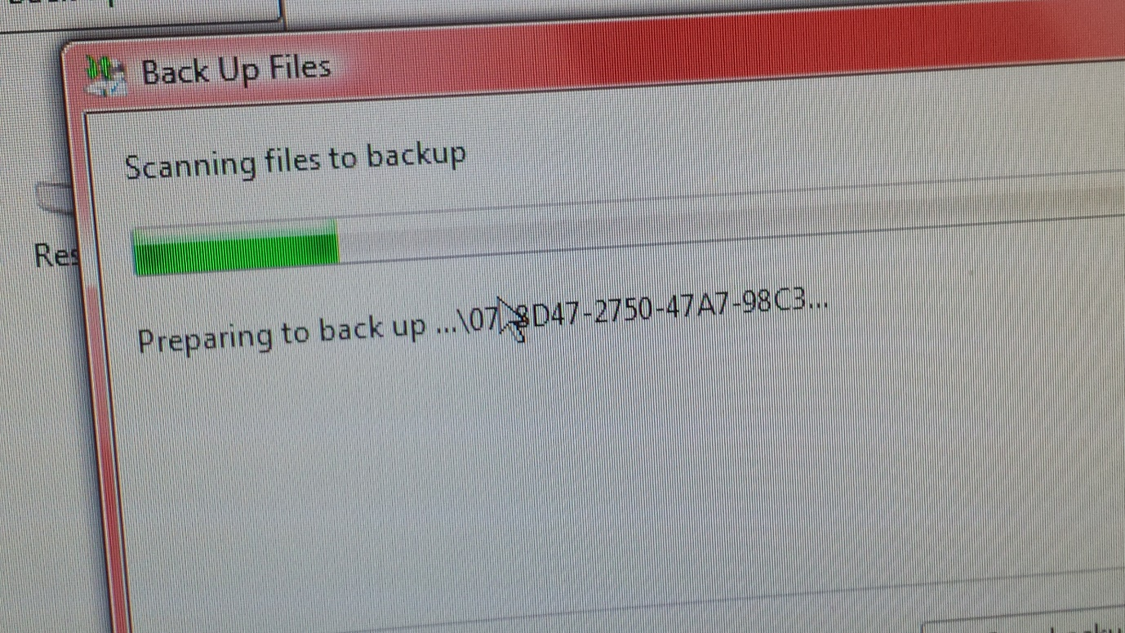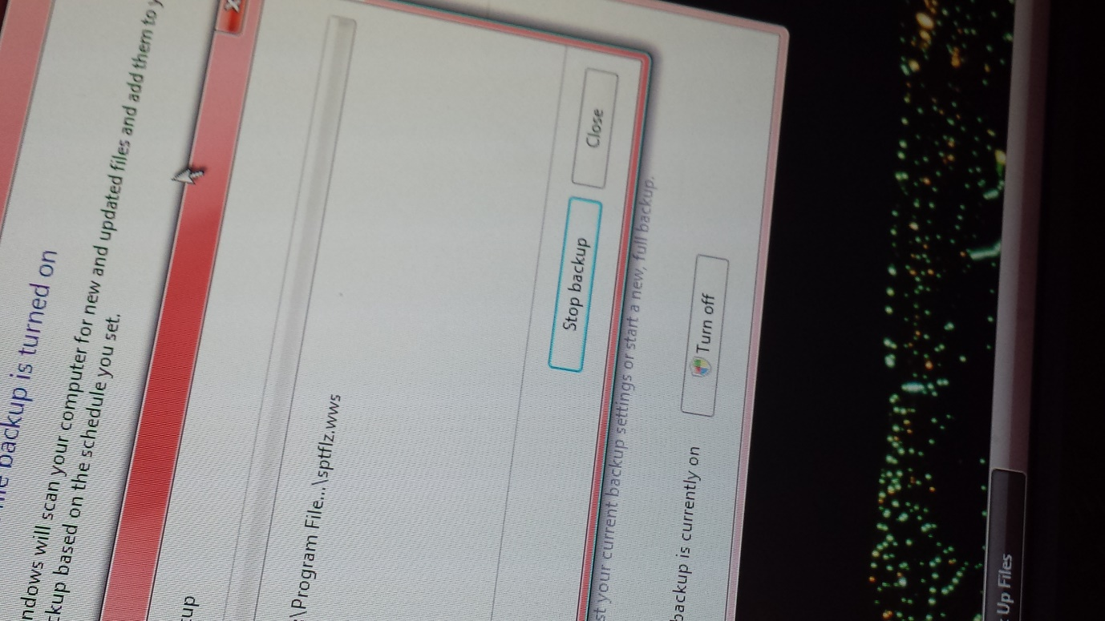

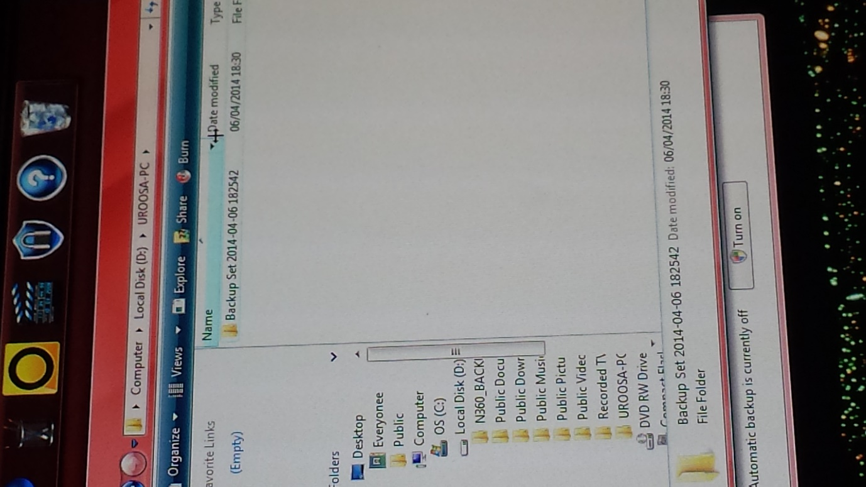As you can see in this image, all the BACK-UP is stored in this place. It gives a clear date of when the data was backed-up.

**Deleting temporary files**

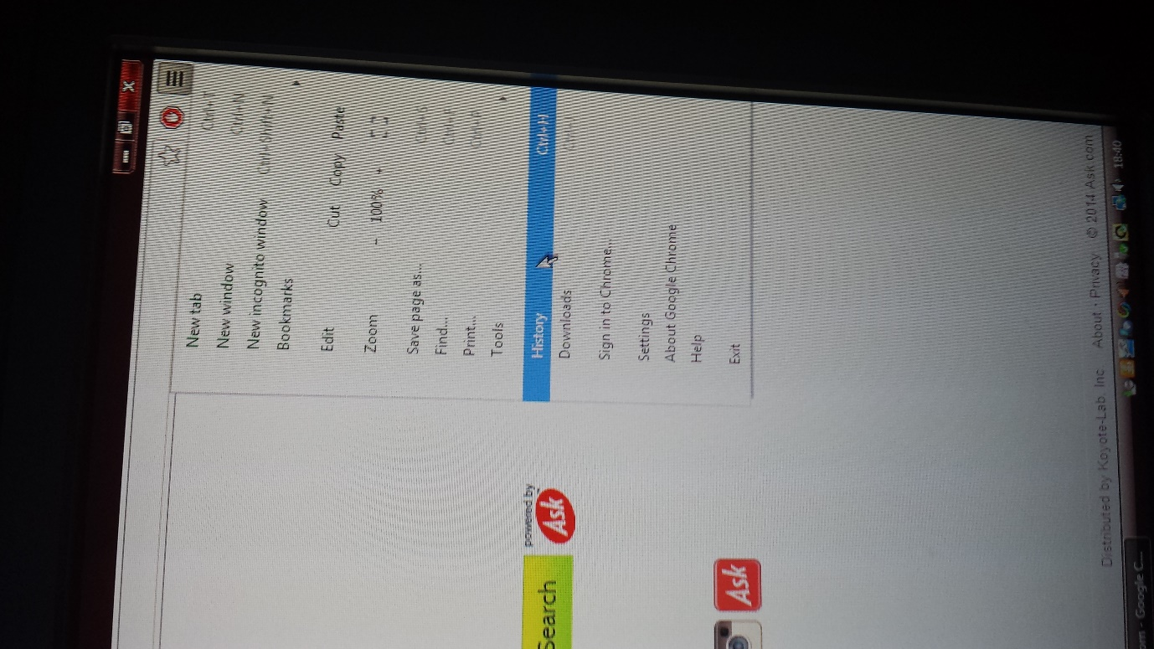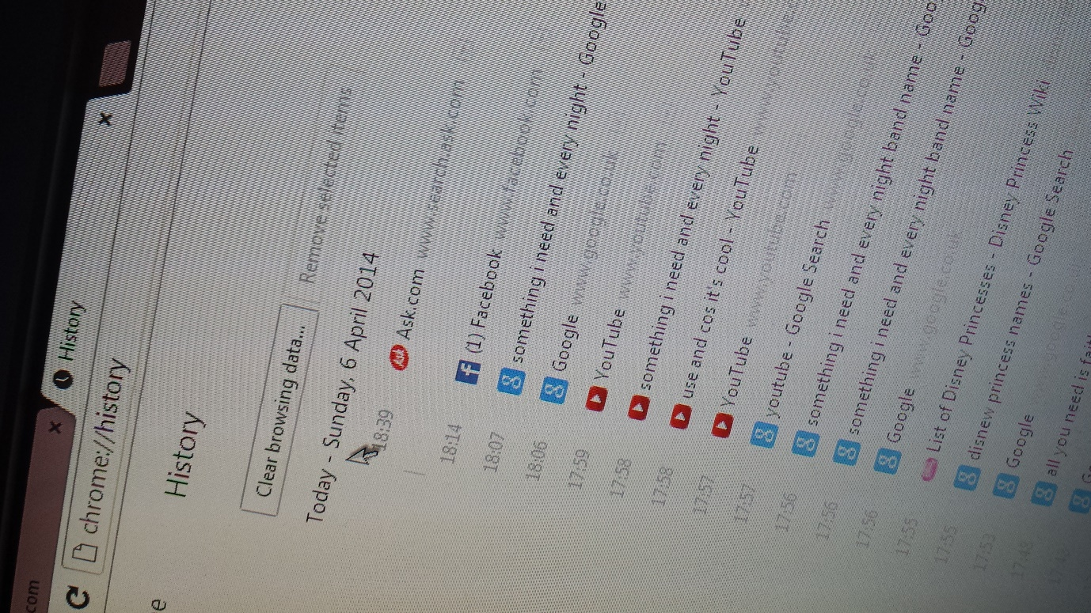To delete the temporary files, you would need to go on your internet browser. I am going to be explaining how to delete temporary files on google chrome. However, if you were using Internet Explorer, it would be the same process. To delete it go on tools and click Delete Browsing History or press on your keyboard, ‘CTRL + SHIFT + DELETE’ and it click delete. For google chrome, press CTRL + H together and all you do is delete it. All your history would appear and clear the browsing data by clicking it.

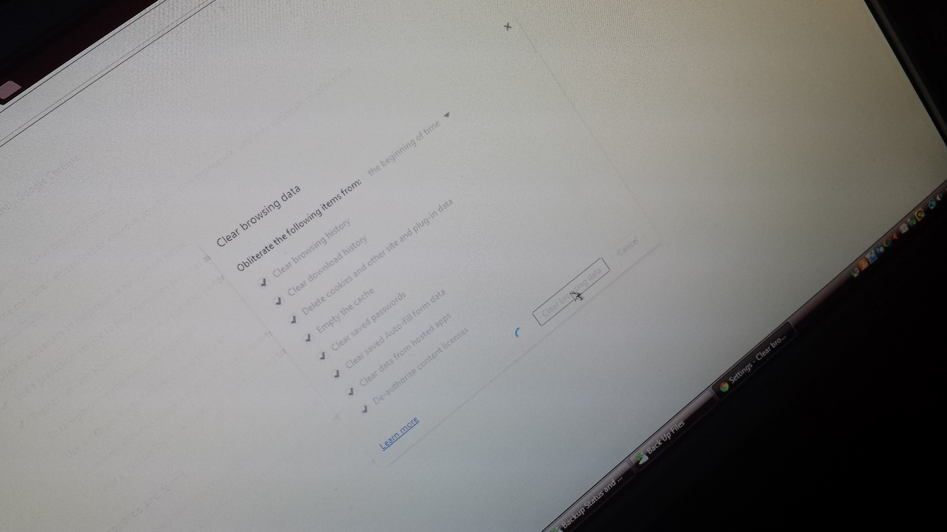

**As you can see on the image below, the temporary files has been cleared.**

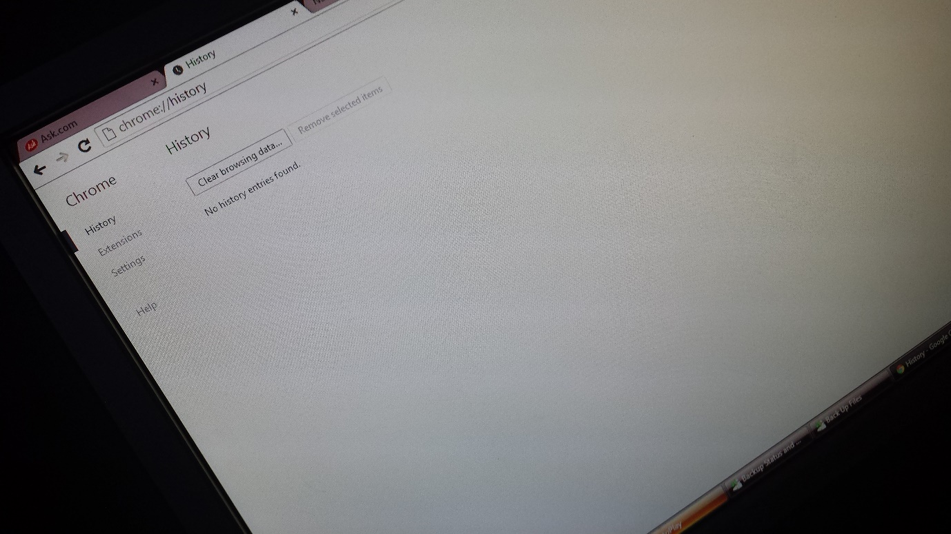

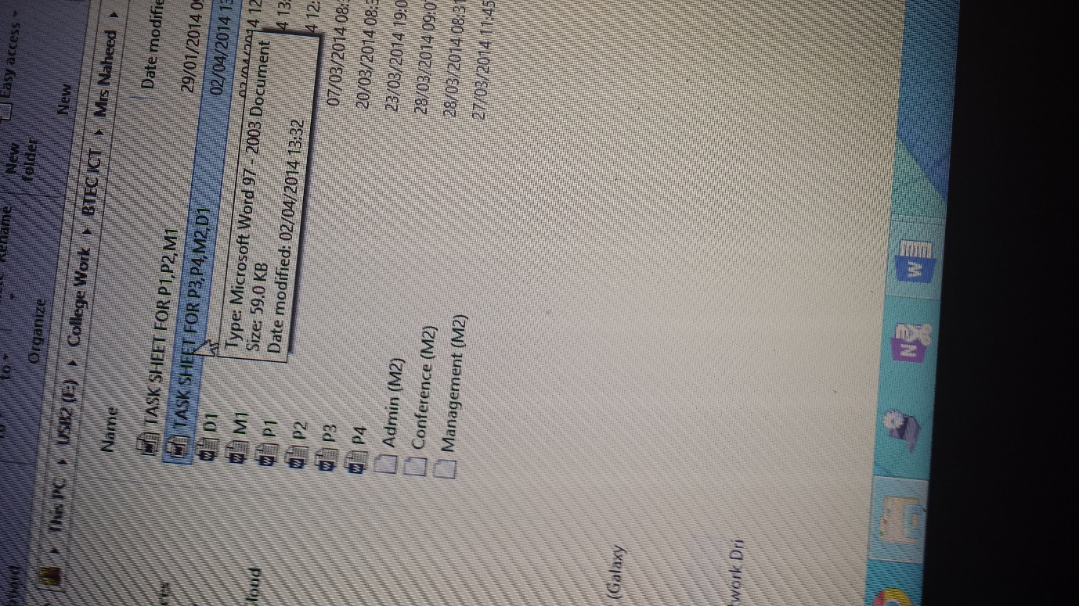**Organisation and naming of files**

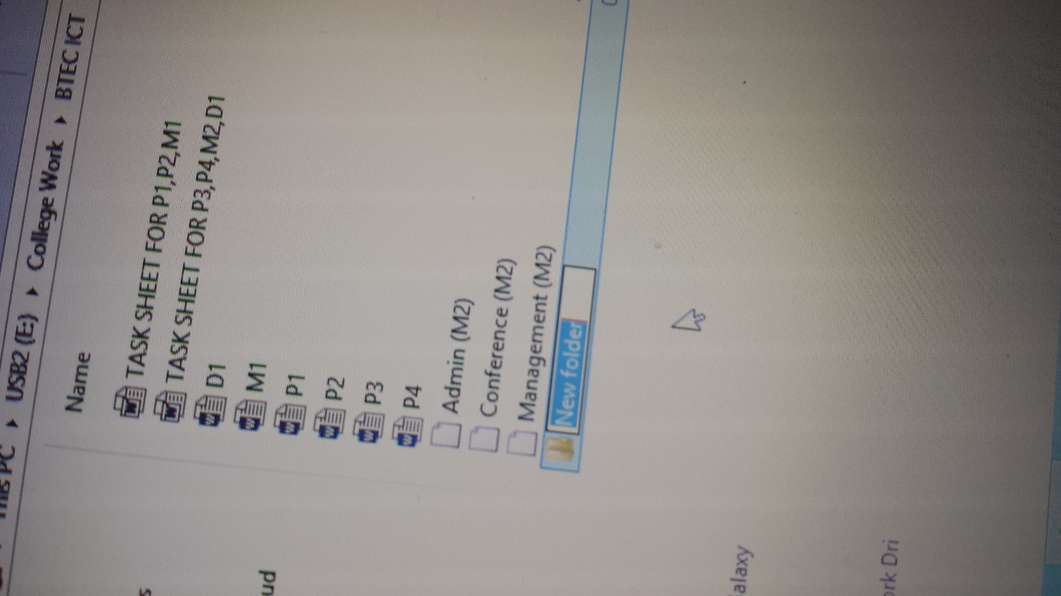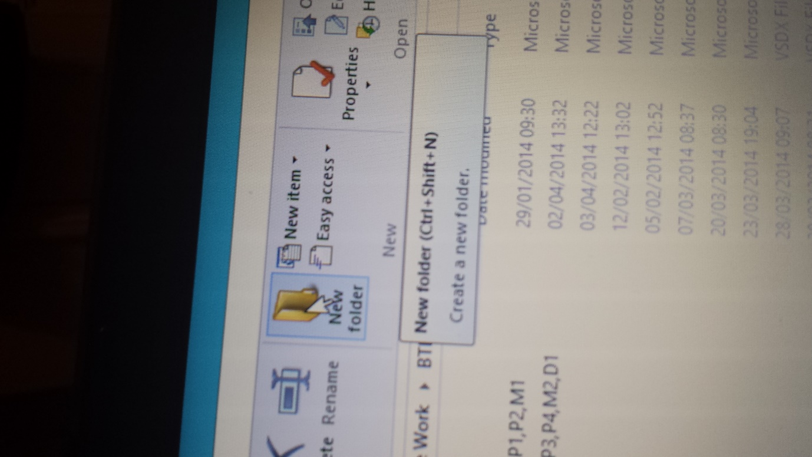As the image shows, it is important we organise and name our files for us to be organised. To organise your files, you would need to put all a file. To create a new folder, you would need to follow the following. It is so simple. You can either press CTRL + SHIFT + N and create the new folder or press the button where it says ‘NEW FOLDER’.

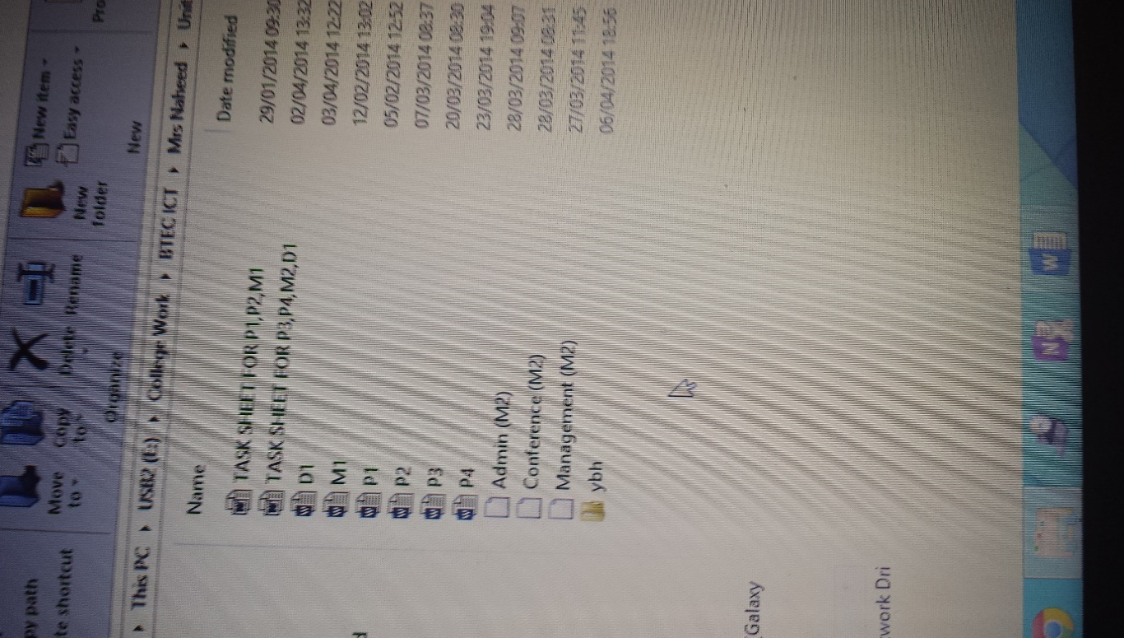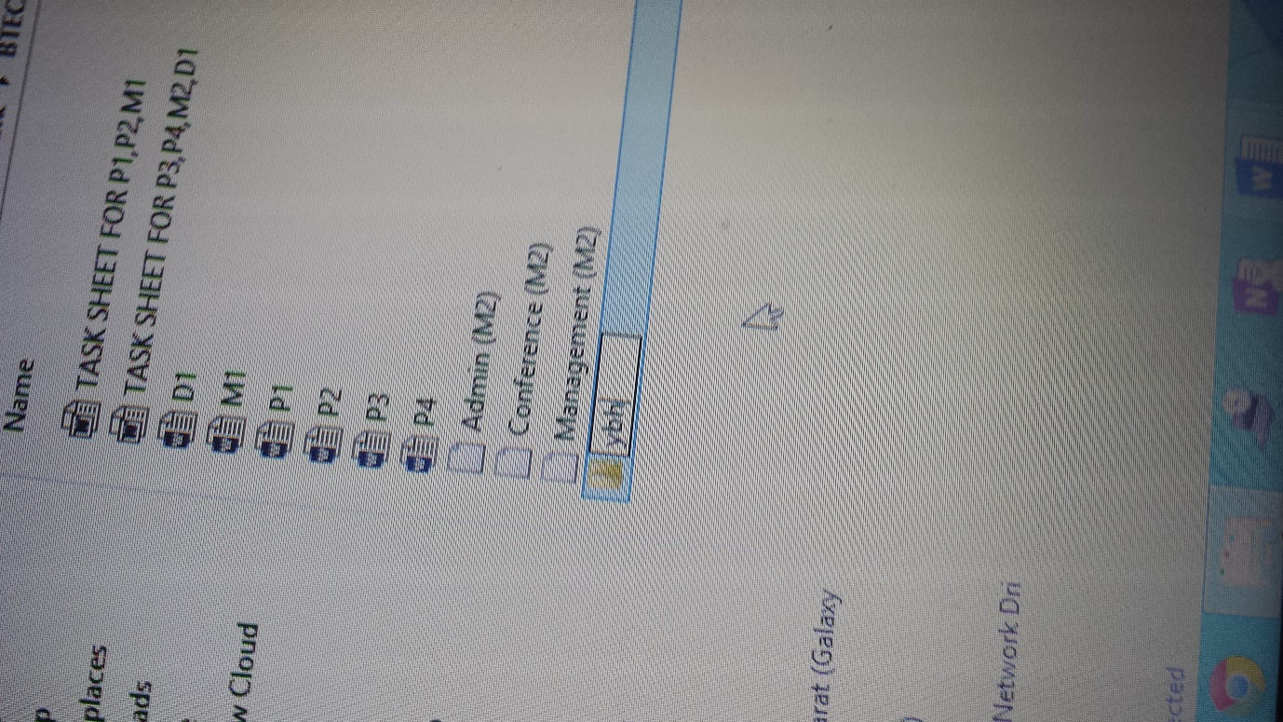As it is highlighted, you would need to name the folder. You can rename the folder by selecting the folder you want to rename. Enter the details you want to rename and highlight the documents/files you want to store in the folder. This organises it and you can rename the folder anytime you want.

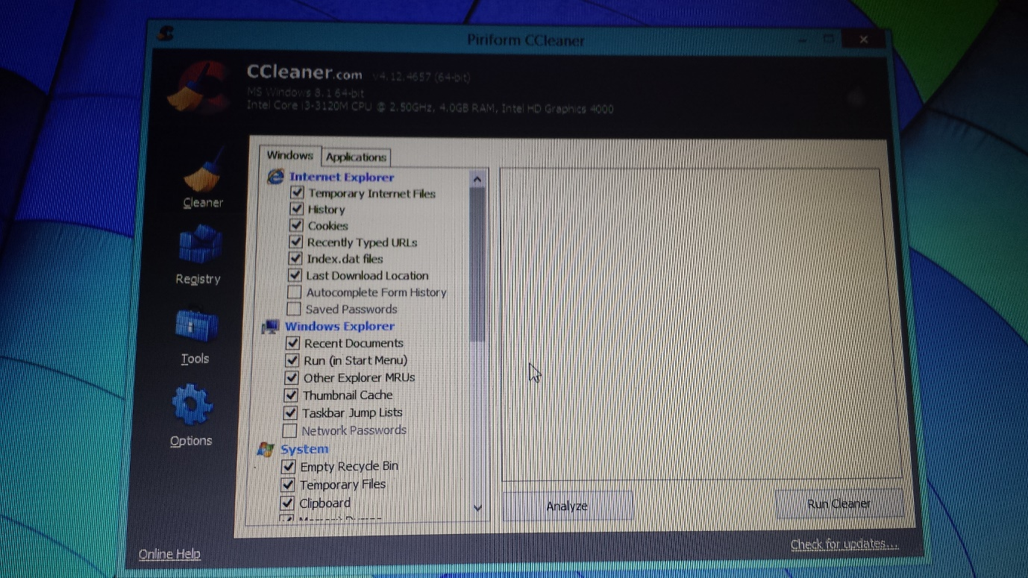**Automatic scheduling and deletion of unwanted data**

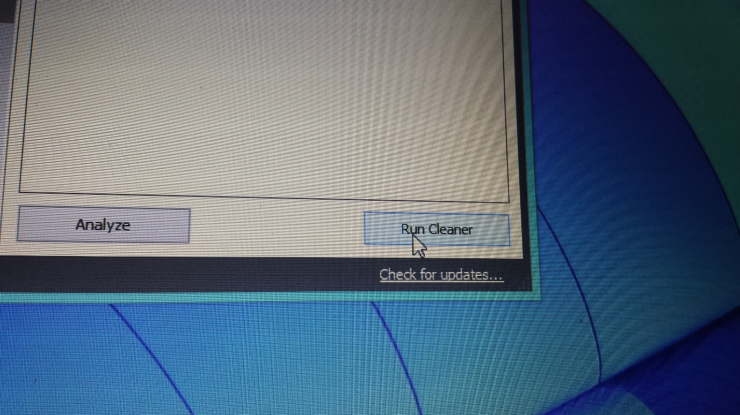They are a numerous ways of scheduling unwanted data. However, I am going to demonstrate another way by downloading a software to scheduling unwanted data. To download this software, type CCleaner into google and click on the first website. Firstly, to delete unwanted data, you will need select the ones you want to delete. It deletes the ones that you do not need and makes the computer more efficient and fast.

Run cleaner after you have selected the items you want to remove. Click ‘OK’ as you want to delete them permanently.

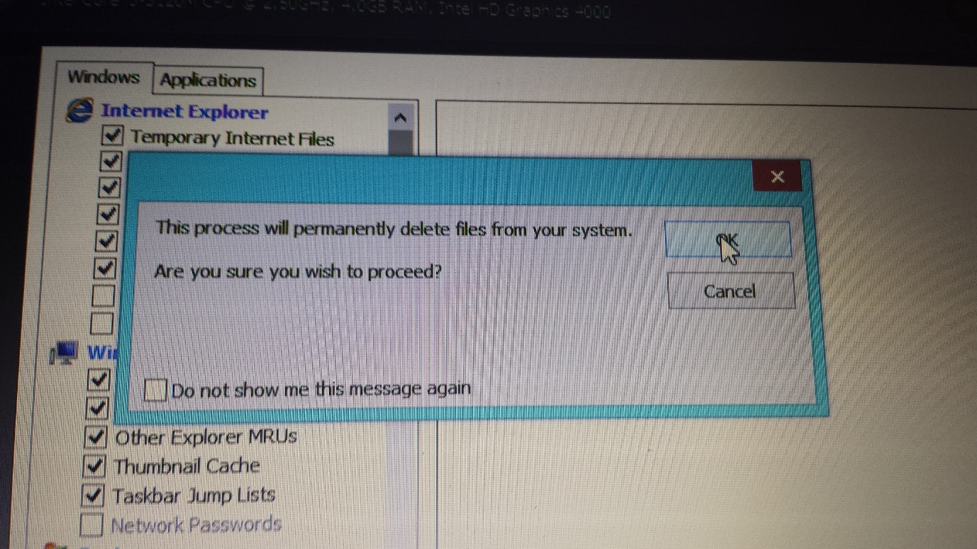

You have to wait until it has to be 100% for it to be complete. After it has been complete, it will give you feedback of what you deleted.

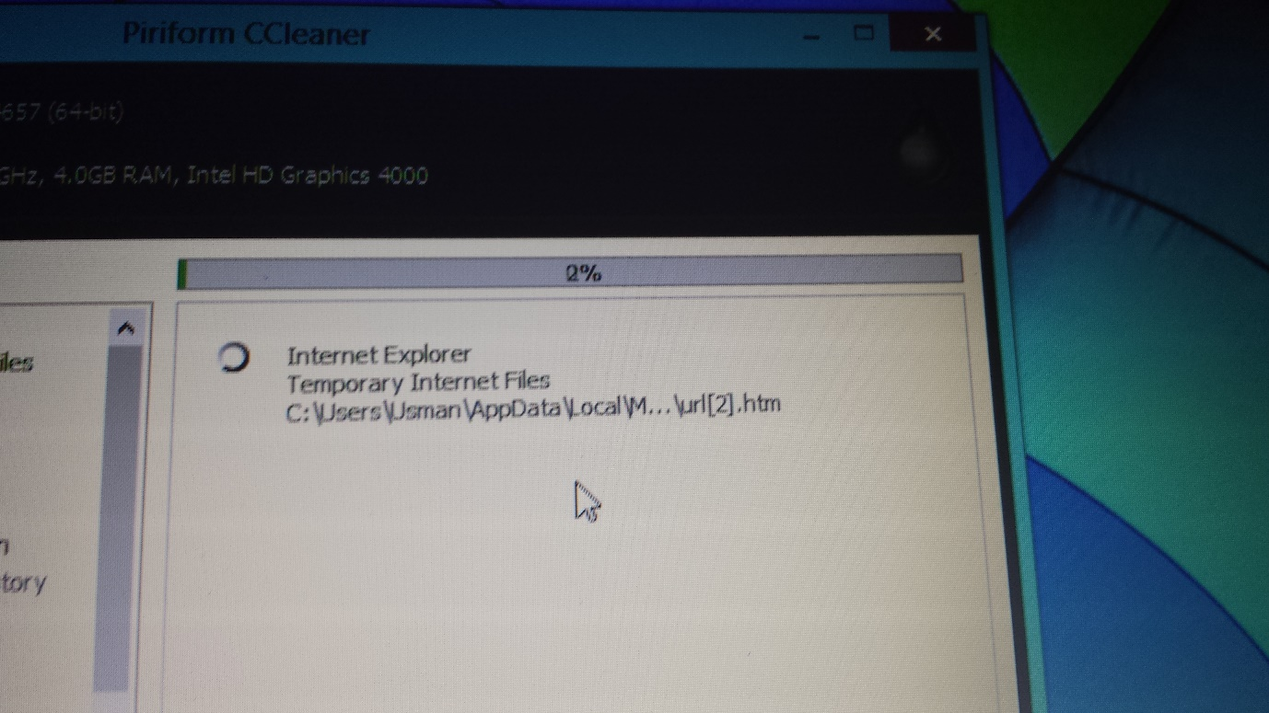

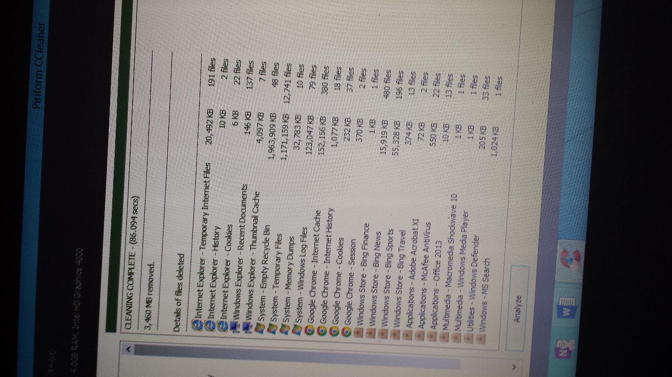

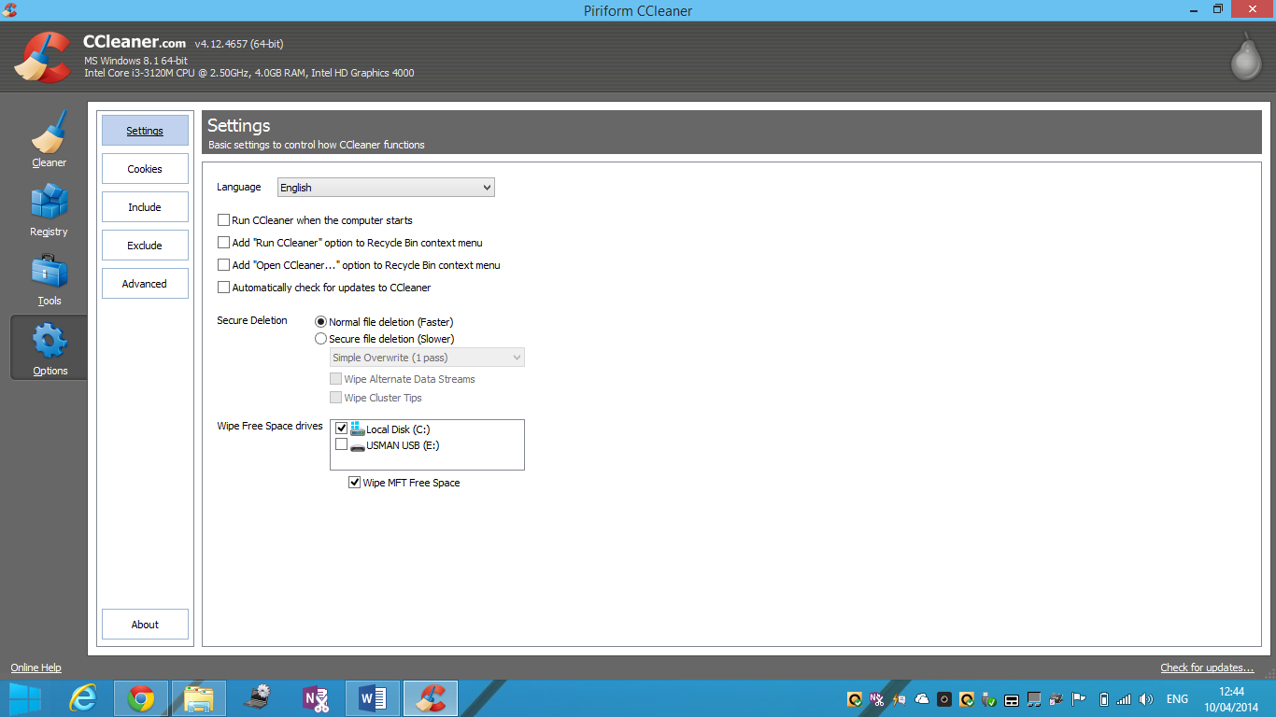You can do this anytime you want, but if you want to schedule this program, go onto options and settings. If you want this program, ‘CCleaner’, to run when the computer starts, it would automatically do it. You can run it whenever you want, but it would do it when you every time you start the computer. Put a tick on the box and close the program, it would proceed with the action. As any program, if you do not understand the language, you can change it.

**Cleaning hardware e.g. keyboard, mouse and DSE**

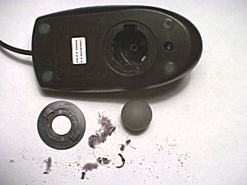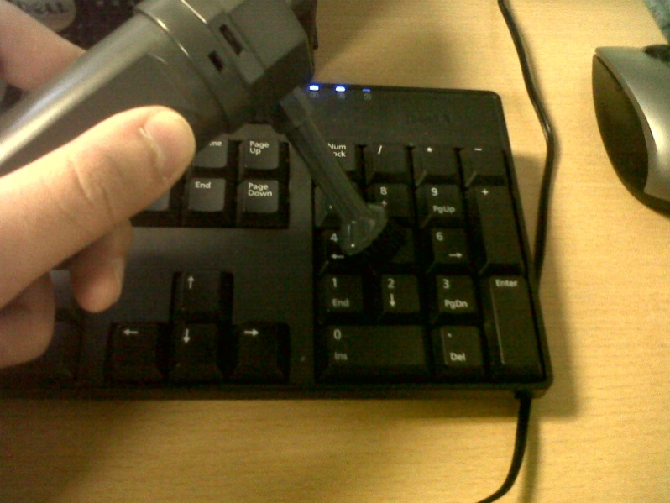Cleaning the keyboard could be the important whilst using the computer. This machine sucks out any dust and remove items that are stuck into the keyboard. It is important that users use this machine every day, because it makes the keyboard easier to use. If anything stuck into the keyboard and it can be removed, it would prevent it from using that particular button. To clean the mouse, you can take out particular parts of the mouse where it there is dust. It makes the mouse much easier to use. You can clean the surface of the mouse as well.

**Display Screen Equipment (DSE)**

DSE is the bases of the way the user sits on the chair. They are dangers of how the user sits on the chair. However, it does depend on how is the chair safe.

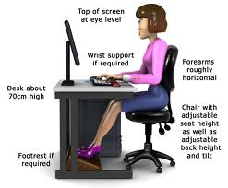

As the image represents, it shows how the DSE should be present. You should have what it says on the picture wrist support if required; forearms roughly horizontal; chair adjustable; desk should be around the same height as the chair; optional for footrest; and top screen eye level.

**Replacing consumables e.g. print paper; ink or toner cartridges; replacing damaged components**

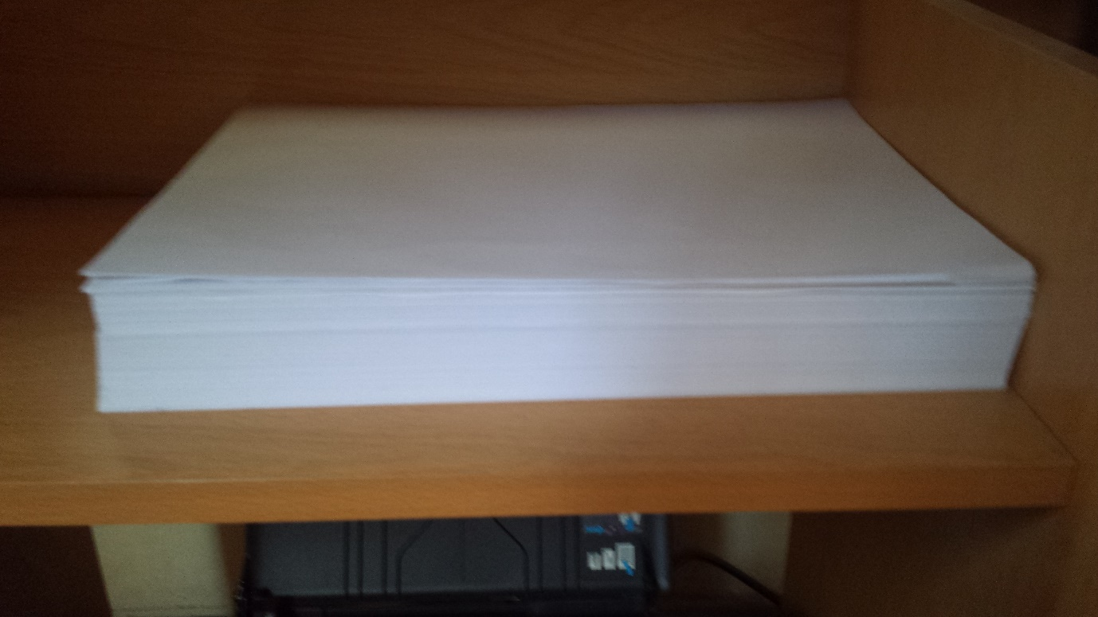Referring to the image below, it demonstrates that this is the paper, which is used for printing documents. It has to be plain for the document. As I am using an ordinary printer, it would not be used in offices. Therefore, it is different compared to what I have in college. All you have to do is get the print paper and slot it into the place where it belongs for the printer to print it. It is that simple. If you run out of paper, get more print paper and slot it back into its place. Do not place the whole lot into it at once, it would not fit, place only a little bit at a time depending on how large the slot is.

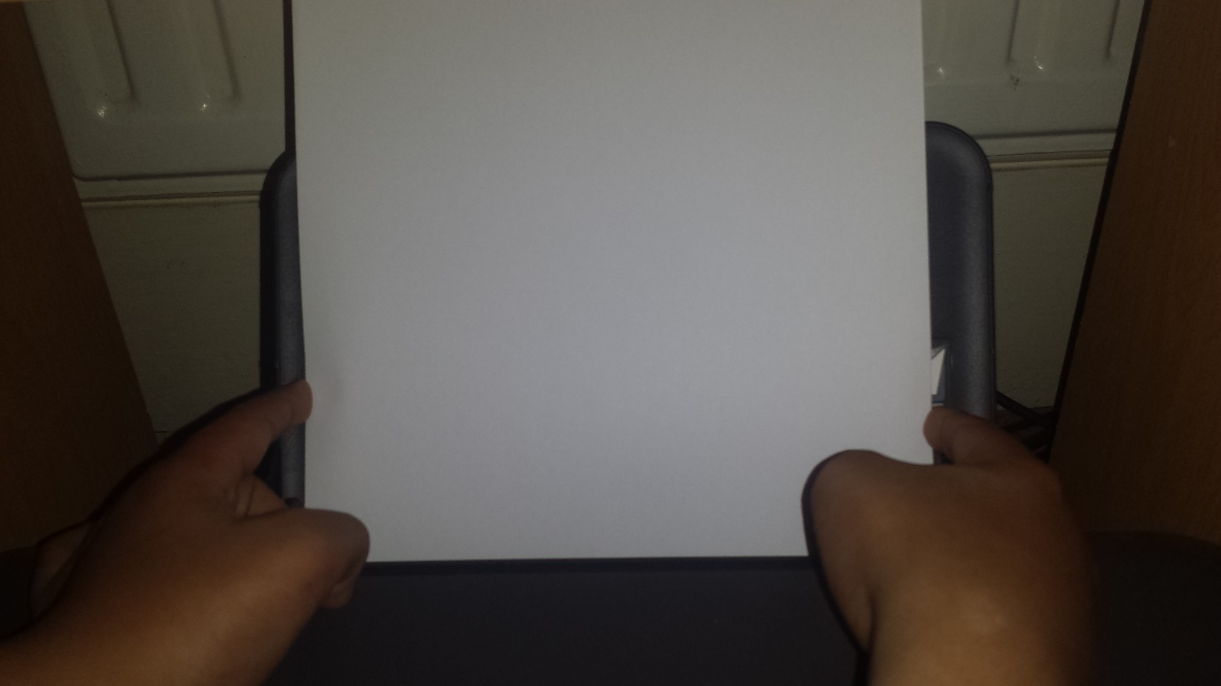

**Replacing ink or toner cartridges**

Replacing the ink cartridges is simple. However, you have to find where it is placed inside the computer. For me, I only have to open two of the doors to get where I am in this picture below. All you have to do it take out the cartridges that are empty and replace them with the new ones. However, you just put any inside there. You have to put the same number that is placed on each one. The coloured one is colour ink and the black one is black ink.

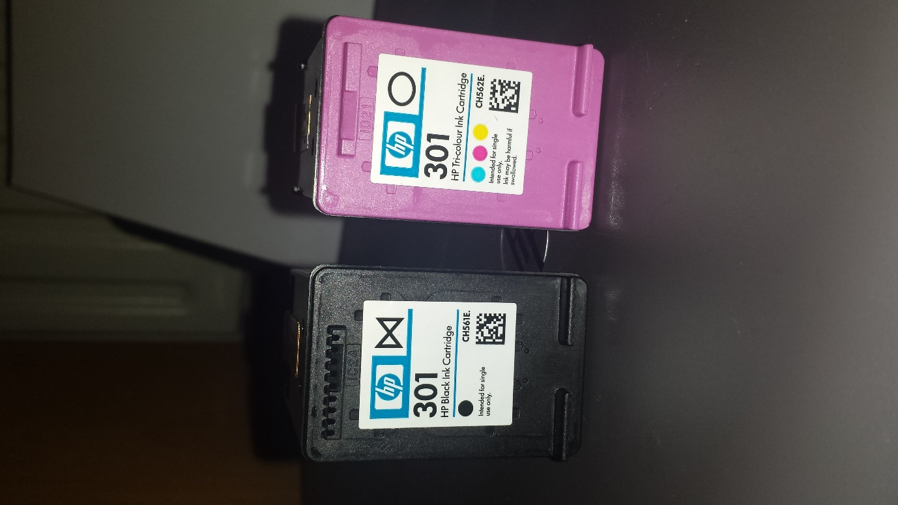 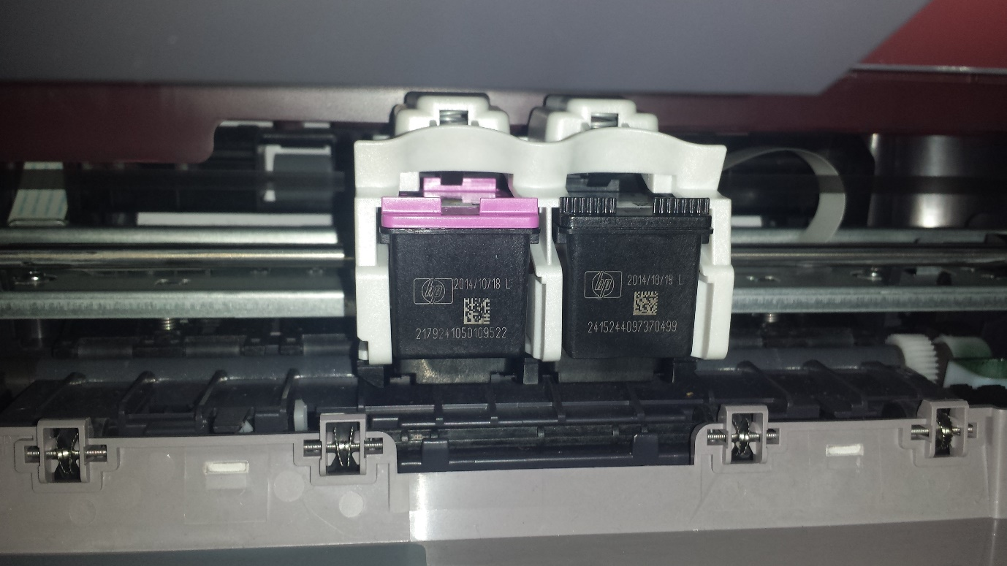

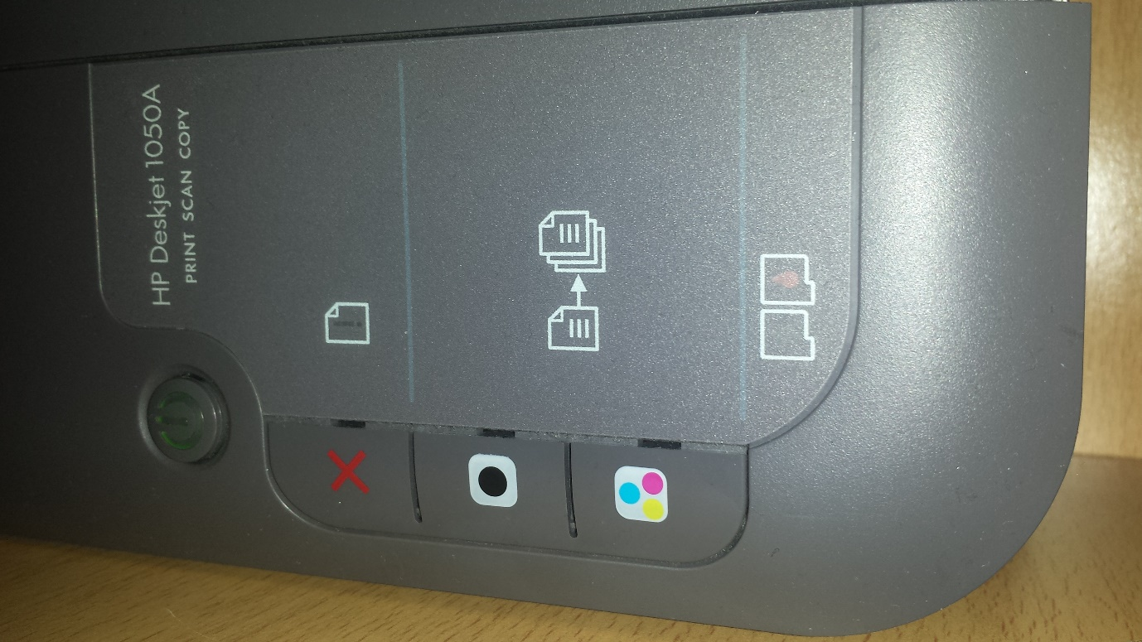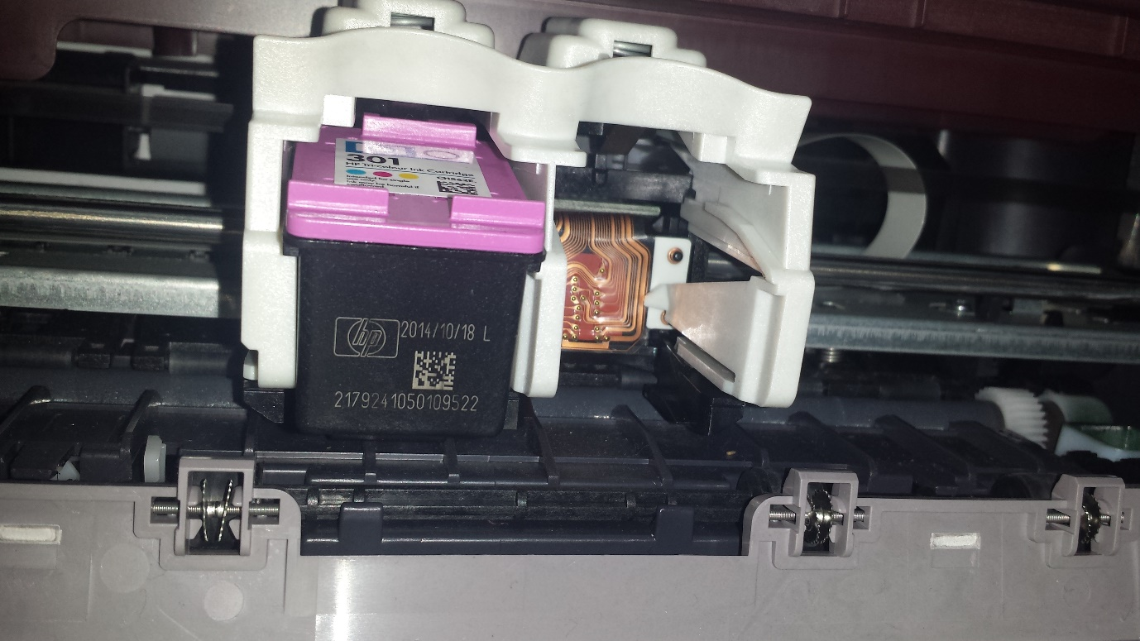

This is an indication of whether the ink is low. The right is the colour and the left is the back. As you can roughly see, the black one is low and needs replacing.

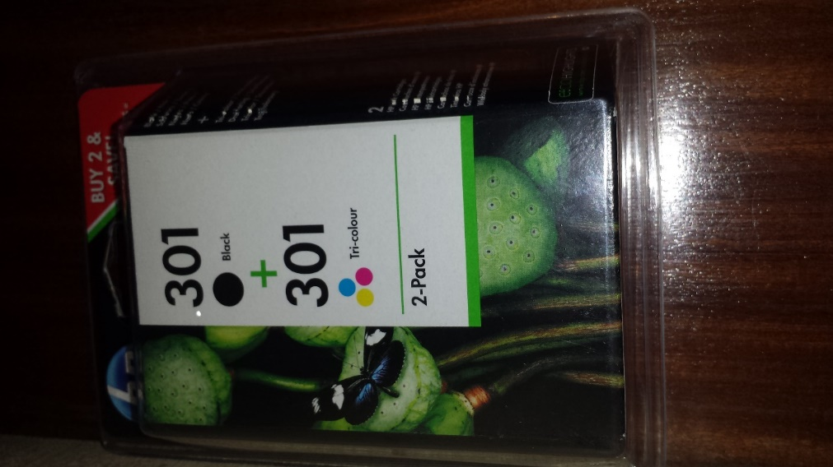

This is the new pack; all you do is replace it.

**Ventilation grills**

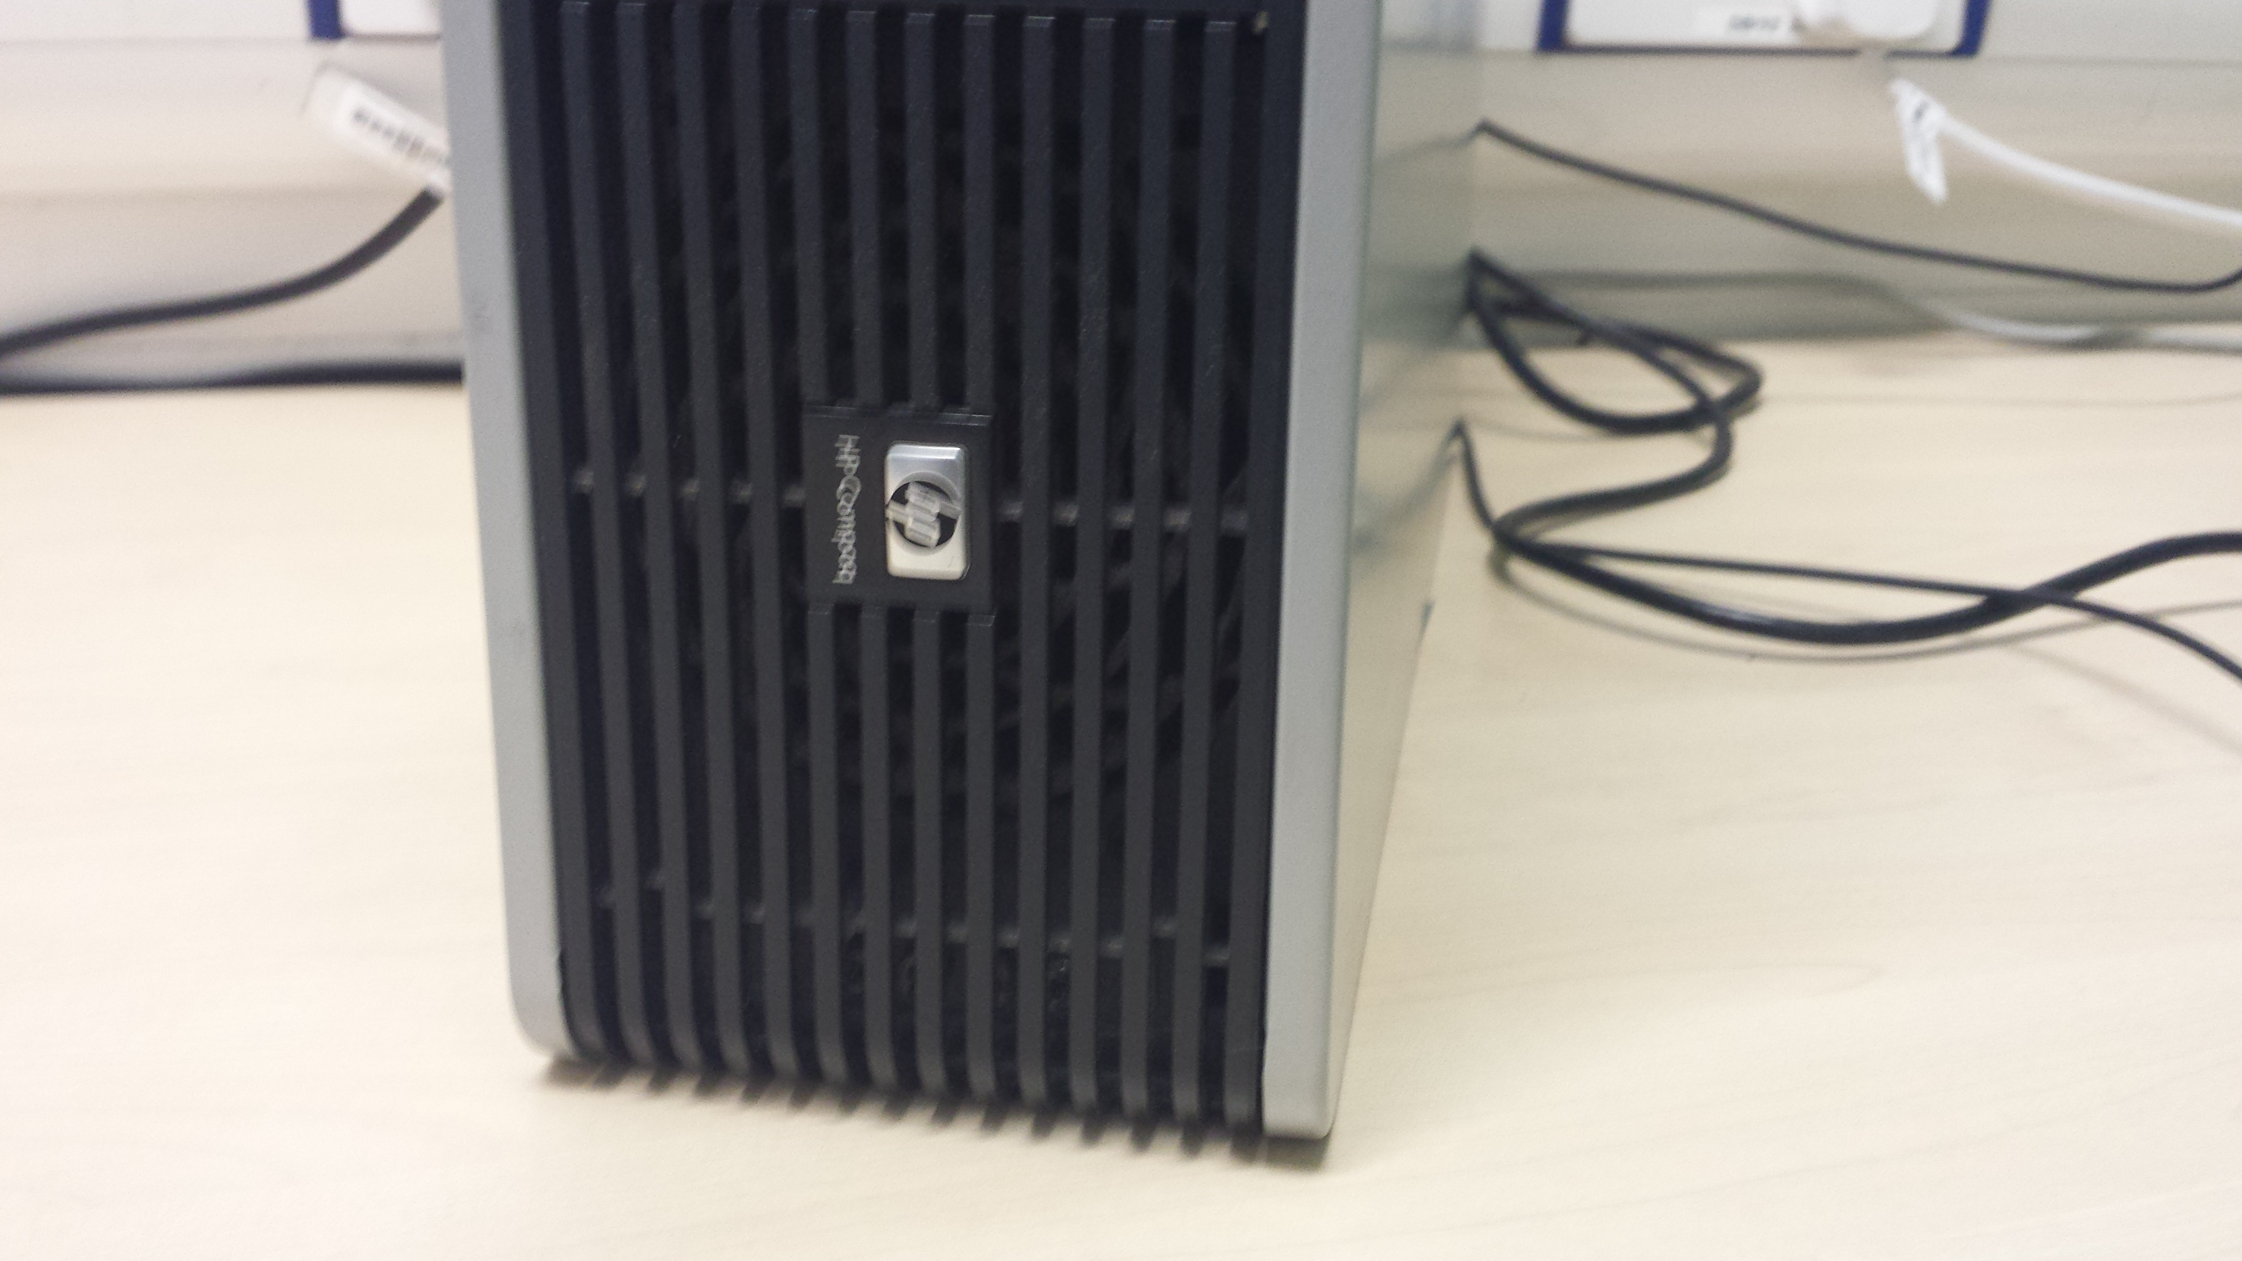

This could be a tricky task to clean. If many dusts have been inserted within the grills, it would be hard for the computer to operate. In computing, it provides fresh air. So, warm air or cold air could be transferred or released. It all collects dust and requires it to be cleaned from time to time. To clean the ventilation grill, you could need to remove the hardware so you see the fan. Clean the fan by using a cloth, or a hover.

**Replacing damaged components**

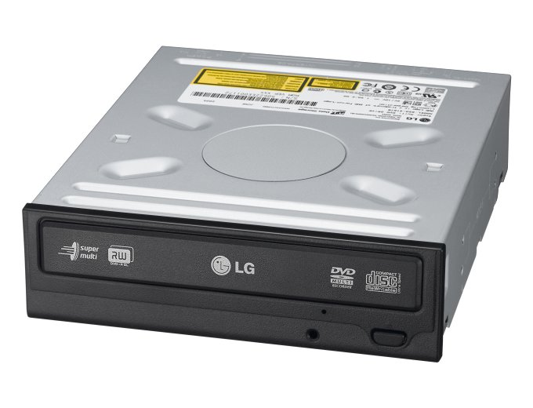Replacing the damaged components could be the CD drive. If you put the CD inside the computer, and it gets stuck, you would need to repair it. Therefore, you would need to take the hardware of the computer. Referring to the image below, you would need to follow it as he is doing it. Take out the disk drive and replace it with a new one. It could be any drive as long as it can fit into the drive. Slot the new drive in and once you press the button, it would work again.

